Build My Future
National Workforce Development Initiative

April 25, 2023
9 AM - 3 PM
Johnson County Fairgrounds
4261 Oak Crest Hill Rd SE - Iowa City, IA 52246
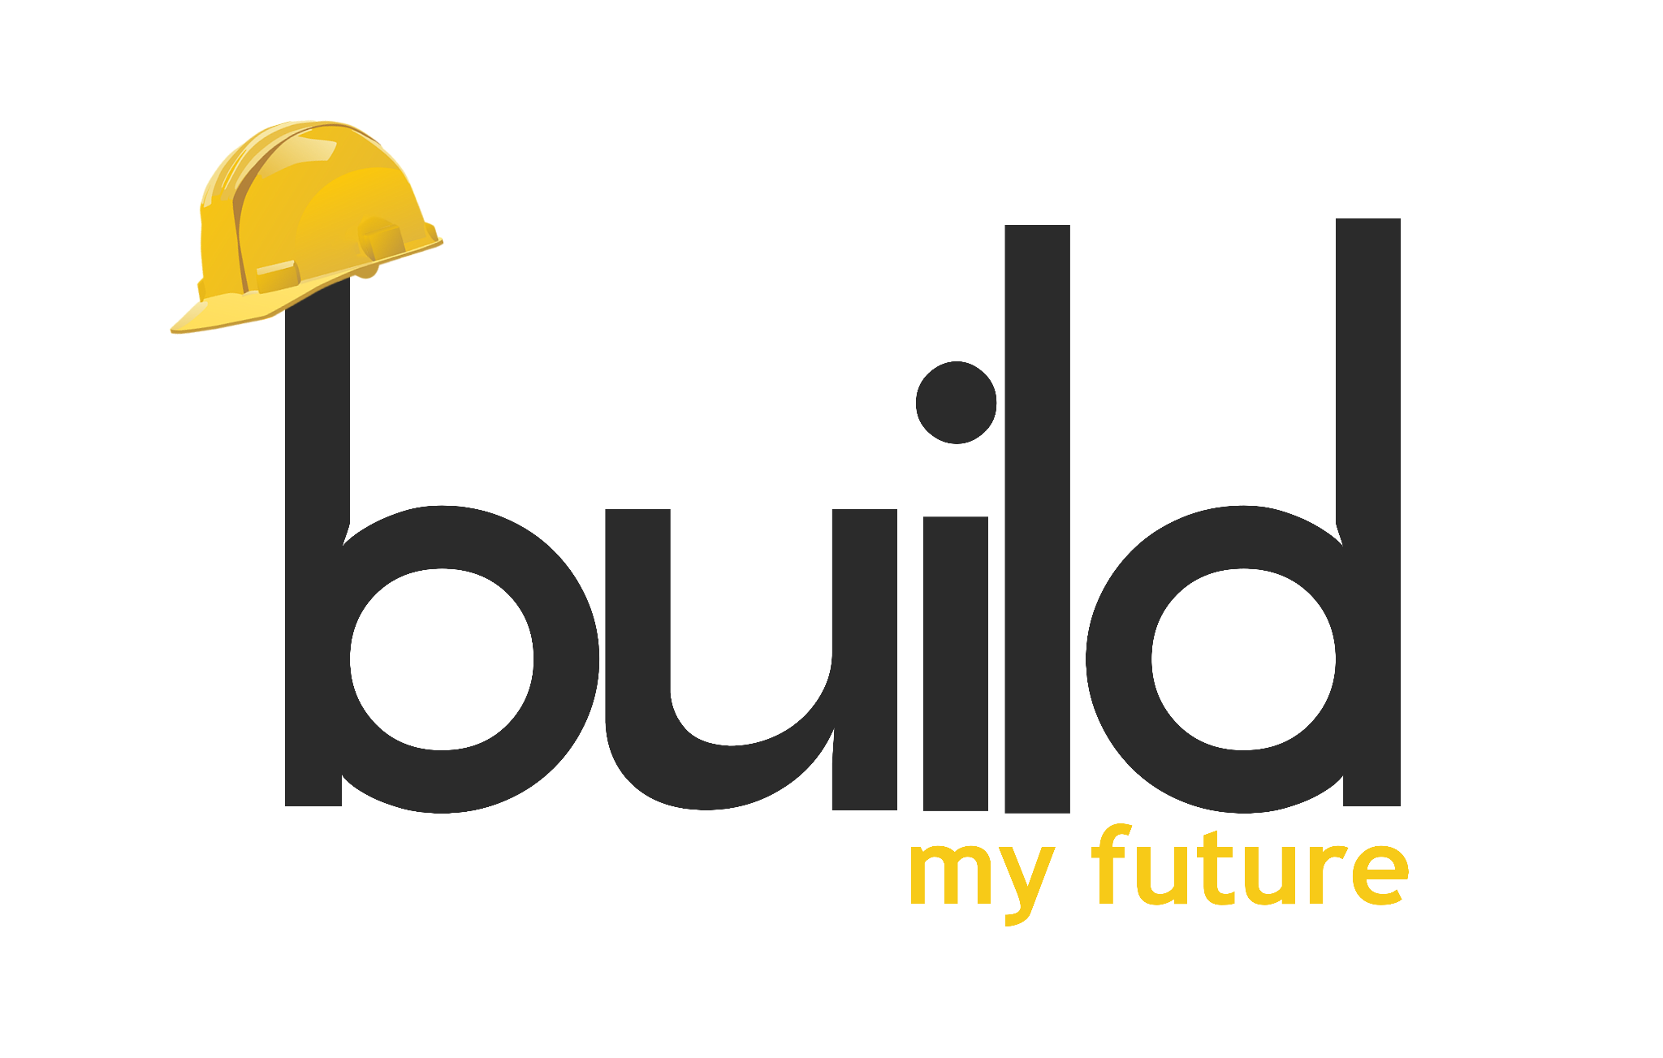

2023 Sponsor & Exhibitor Package

Build My Future is free for students to attend. This event is for 9th -12th grade high school students in eastern Iowa. We are expecting the majority of students will come from Benton, Washington, Linn, Jones, Johnson, Cedar, Louisa, Muscatine, Scott and Iowa counties. Build My Future is a national workforce development initiative started in Springfield, MO to highlight careers through hands-on training provided by local employers, educators and skilled trades associations.

2023 will be the 3rd annual Build My Future event in the ICR region. It is hosted by Future Builders of Iowa, a non-profit organization created to expand workforce development initiatives in eastern Iowa in partnership with the local Iowa Home Builders Associations. It is the first year all the high schools in eastern Iowa are invited to participate in hands on training in a wide range of activities including: roofing, siding, framing, hanging and mudding drywall, plumbing, door hanging, GPS surveying, excavator and underground utilities, job site supervisor, rebar tying, old methods vs. new technologies, brick laying and many more.

Through these experiences the students not only learn about the craft behind a wide range of trades, but they also engage in conversations with experts about what kind of training is needed, wages, working conditions/typical day, and opportunities within the industry.

We would love to have your partnership in this event! Without industry support, this event wouldn’t be possible, and our future workforce may never experience your trade firsthand. As a sponsor and/or exhibitor, you will have the ability to directly interact with students to showcase your career opportunities!

2023 Sponsorship Levels

Visit https://explore-ace.org/ to learn more about the portal.

Level | Amount | Description
Master | $1,500.00 | Event  - Large sized logo on t-Shirt  - Professional recorded interview (recorded at event)  Portal  - Large logo on portal  - Company page on portal with link to company site  - Interview video featured on the portal and Facebook  Logo  - Email logo in Vector format: amy.futurebuildersiowa@gmail.com
Foreman | $1,000.00 | Event  - Medium sized logo on t-Shirt  Portal  - Medium sized logo on portal  - Company page on portal with link to company site  - Interview video featured on the portal and Facebook  Logo  - Email logo in Vector format: amy.futurebuildersiowa@gmail.com
Journeyman | $500.00 | Event  - Medium sized logo on t-Shirt  Portal  - Medium sized logo on portal  - Company page on portal with link to company site  Logo  - Email logo in Vector format: amy.futurebuildersiowa@gmail.com
Apprentice | $250.00 | Event  - Small sized logo on t-Shirt  Portal  - Small sized logo on portal  - Company page on portal with link to company site  Logo  - Email logo in Vector format: amy.futurebuildersiowa@gmail.com
Friend of Industry | Amount of choice | Event Company name included on t-shirt
Exhibitor Only | - | Event Company name included on t-shirt

2023 Sponsor and Activity Registration Form
Thank you for your participation.
Form and Payment must be received by March 6, 2023.

Company: ________________________________________________________________________
Contact: ________________________________________________________________________
Address: ________________________________________________________________________
Phone: ________________________________________________________________________
Email: ________________________________________________________________________

Sponsor Level (All sponsors are encouraged to also be an exhibitor, but it is not required.)
_______ Master $1,500 _______ Apprentice $250
_______ Foreman $1,000 _______ Friend of Industry (Amount $_________)
_______ Journeyman $500 _______ Exhibitor Only

Exhibitor Information
Title of Activity: __________________________________________________________________
Description: Please describe the demonstration and student involvement.
____________________________________________________________________________________________________________________________________________________________________________________________________________________________________________________________________________________________________________________________________________________
_______ Access to electric is required
_______ Number of anticipated exhibitors at activity
All exhibitors must complete the included facility use agreement and provide proof of liability insurance.
Completed registration includes
_______ Registration Form
_______ Facility Use Agreement
_______ Proof of Liability Insurance
_______ Check Payable to “VTC-Future Builders of Iowa” with the memo: “Build My Future”
Mail completed registration to
Amy Pearson, Future Builders of Iowa, 6516 Woodland Ct., Davenport, IA 52807

